TaskList VMWare

Single-instance all instances of the following Script’s code (and similar) using a single vRO Workflow:

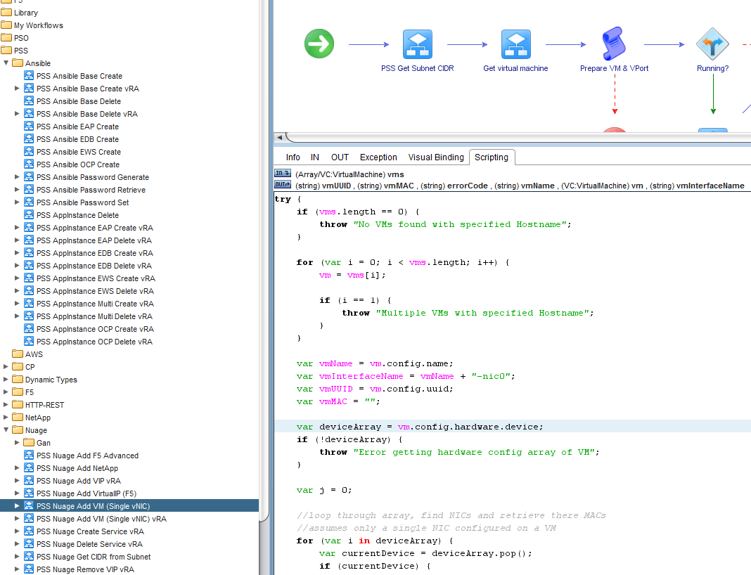

Remove the hardcoded JSON in the following Script’s code (and similar) by leveraging vRA Configuration functionality, in the exact same manner as has been done with “PSS Ansible Base Create”.

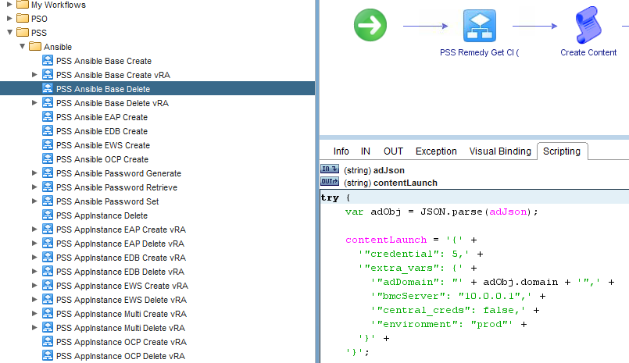

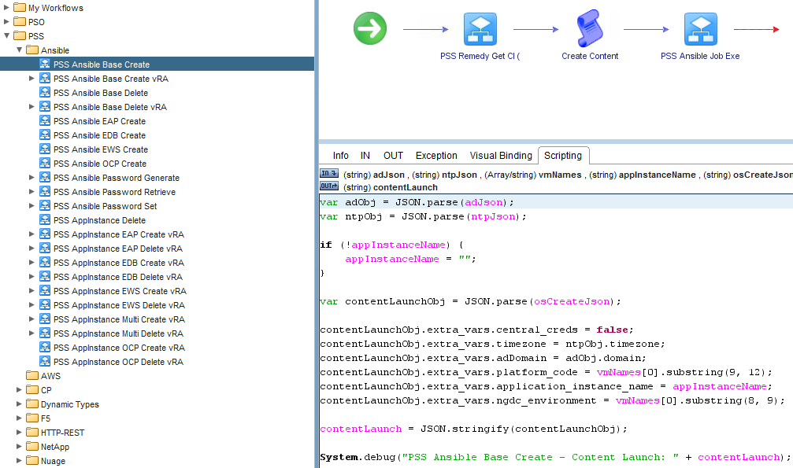

Duplicate the following Avnet RemedyForce vRO Actions similar to the existing two duplicated vRO Actions into the “com.prudential.pss” folder & modify them in the same manner (i.e. simple 3-retries logic):

* RemedyForce_GetRecord
* RemedyForce_GetAllRecords
* RemedyForce_CreateRecord
* RemedyForce_DeleteRecord

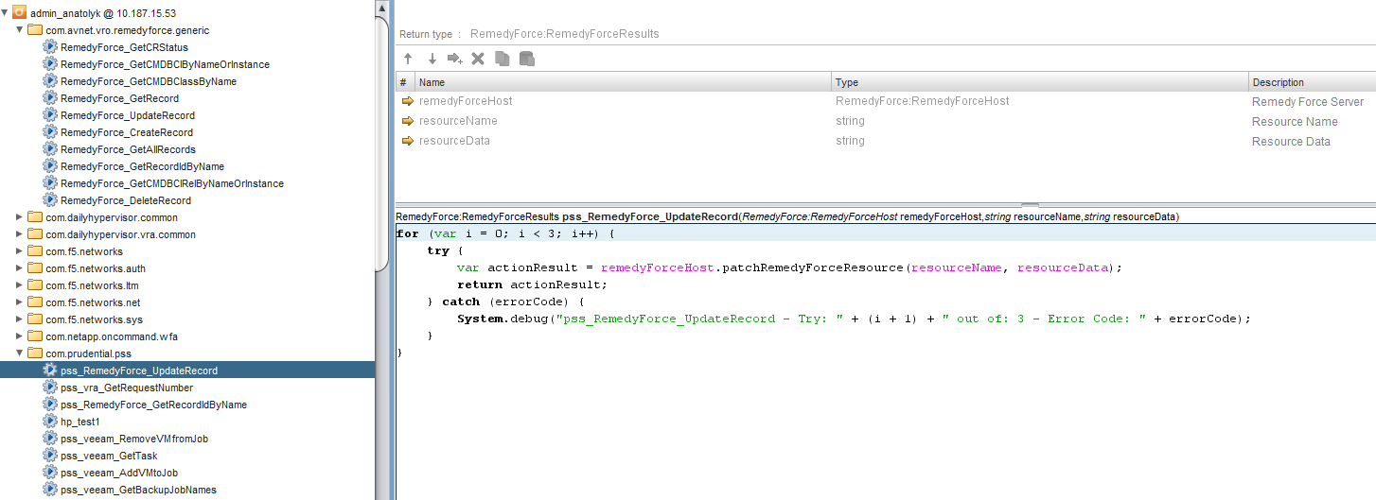

Then replace all references to those vRO Actions in vRO Workflows in the “pss” folder to the improved vRO Actions. Any existing (redundant-resulting) retry logic contained in vRO Workflows is to be removed. For example:

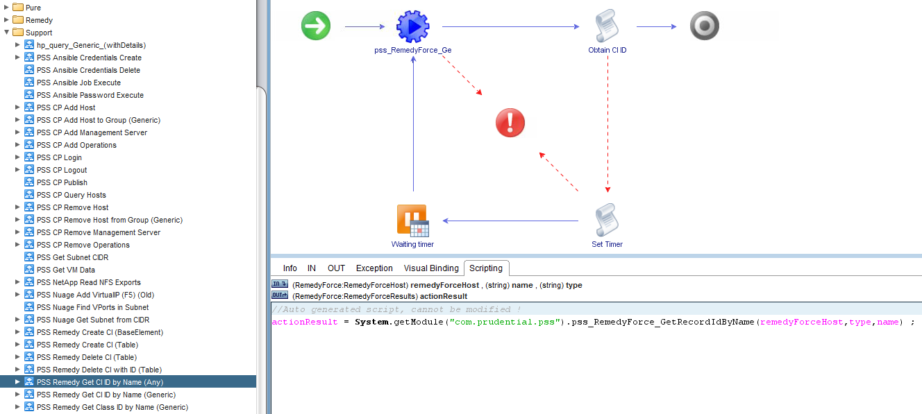

Advanced - Replace each of the 4 types of vRO Workflow with a single vRO Action maintaining the same Input, Output & Functionality (this will result in much faster execution of Dynamic Types vRO Inventory population):

* Find All
* Find … By Id
* Find Relation
* Has … Children in Relation

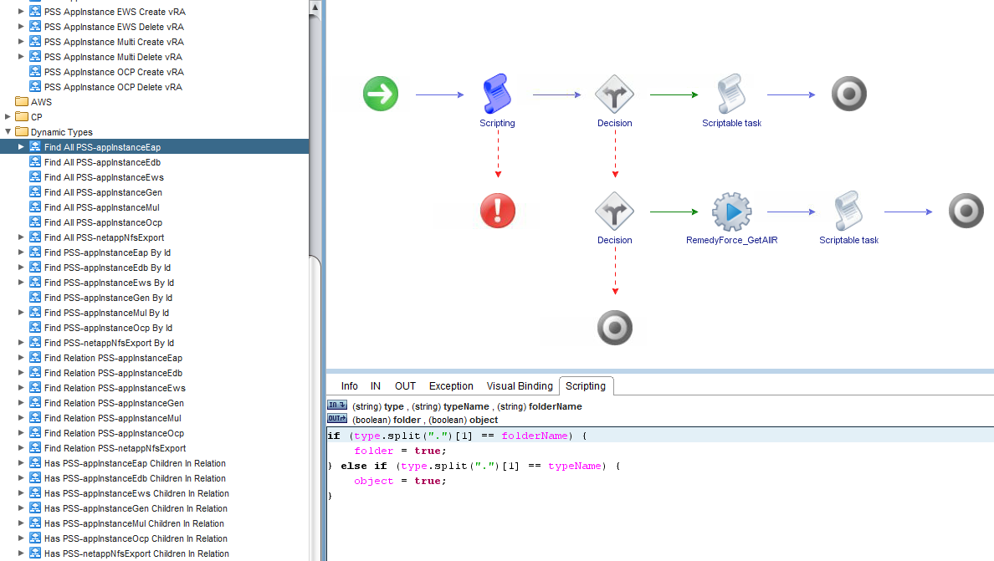

In general:

* Prefix any System.debug or System.log output with the name of the vRO Workflow (aids with tracking where the code is, which has generated the log entry). Please modify where not the case.
* Remain strictly aligned with the existing prevailing naming convention & coding format (e.g. Use of upper- & lower-case, code spacing & indenting, bracketing, new-lines)
* Only vRO Workflows in the following sub-folders (within “PSS”) are to be modified (others are deprecated or system-generated, etc.):
* + Ansible
  + Dynamic Types (only for RemedyForce vRO Action replacement)
  + Nuage
  + Other
  + Remedy
  + Support
* Please note that Arrays are in use in various places where best practices would dictate one should use JSON or Properties. This is due to vRO’s requirement in using an Array to perform Workflow execution repetition.
* Please make a note of any other code, which would benefit from refactoring, while keeping in mind the target audience for future Code maintenance/understanding/troubleshooting does have an Operations background (not Development background).